Introduction: Whatever goes up must come down. We know this from simple gravity knowledge. When one throws a ball into the air, the ball comes down. When a rocket is projected into the air, the rocket hits a certain maximum and then proceeds back to the Earth’s surface. We can measure the paths of these objects by using parabolas. Quadratic graphs are also everywhere in the real world. McDonalds is the most popular fast food restaurant around the world and two parabolas represent their logo (see below).
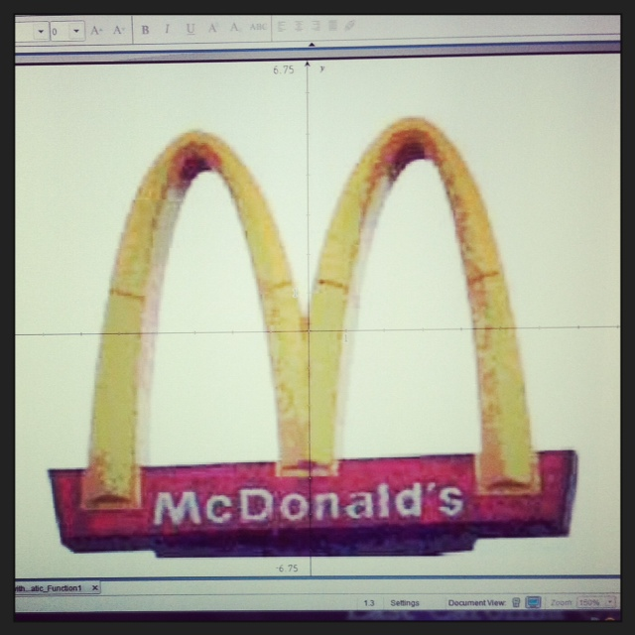
It is important for students and for teachers to understand how important parabolas are. Explorations should be done by students to fully understand the properties of quadratics. The exploration I have created was done on a TI Inspire software. The activity gives and shows detailed exploration on how a parabola changes when tweaking a variable. The graphs being examined all use the same basic formula of y= ax^2 +bx +c.
Slider Exploration for variable a: When I opened up TI Inspire I selected the Graphs function and then began my exploration. I typed in the function for a quadratic by pressing tab and typing in the information. For the first graph I looked at I kept b and c constants. I let b=2, c=3, and then I created a slider for a. The function read y= ax^2 +2x + 3. I created a slider for a by clicking on the Actions tab on the left side of the screen and chose the very last option of “insert slider.” I then changed the variable to a and right clicked the slider application. After I right clicked, I changed the settings so that the minimum was at -10 and the maximum was at 10. I also changed the step size to 1. I first looked at the positive side for a. I noticed that as a got bigger, the graph became skinnier. The first graph below I set a=2. The second graph below I set a=9. I can defintly see how the graph became thinner. We should consider that when a is positive we have a minimum value at the vertex of the parabola.
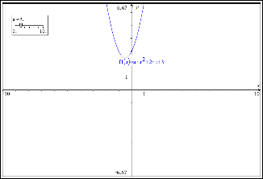
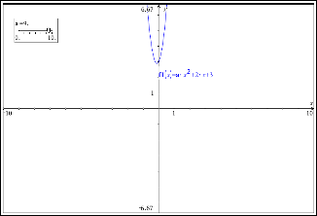
Next, I looked at what happened when a was equal to 0. Students and teachers should know that when making a=0 that the graph becomes a linear equation because we no longer have the x^2 variable.

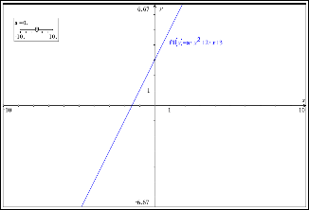

Lastly, I examined the negative side of a. We should know that when a becomes negative the graph flips. We now have a maximum at the vertex of the parabola instead of a minimum. I set a=-1 for the first graph below and a=-7 for the second graph. As the absolute value of a became larger, the graph became thinner. The same thing happened for the positive side of a. So we can conclude that the a value determines whether the graph will have a maximum or minimum value at the vertex and the thinness of the graph.

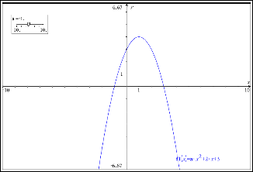

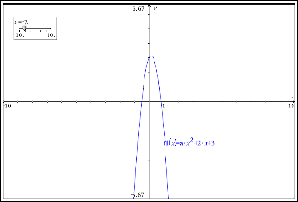

Slider exploration for variable b: For the exploration for the variable b I followed the same procedures that I did for a. I added a new document to the TI Inspire page and selected the graphs option. I typed in the function for a quadratic and set a=2, c=3, and created a slider for b. The function read y=2x^2 + bx +3. I set the variable in the slider to b and then edited the settings and made the maximum 10 and minimum -10. I also changed the step size to 1. After I did this I looked at when b=0. I noticed that the y axis of the graph created a perfect line of symmetry for the parabola. The y axis also goes straight through the vertex of the parabola at the minimum.

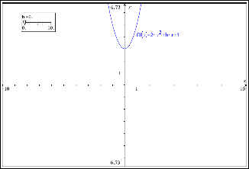

Next I let b=2 and b=8. As the b value gets larger, the graph shifts down and to the left or negative side of the graph.

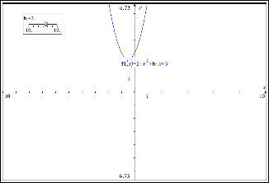

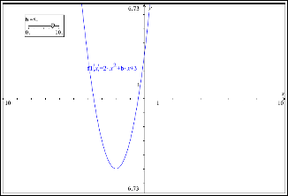

Next, I let b=-4 and b=-8. As the absolute value of b got larger the graph shifted down and to the right or positive side of the graph.
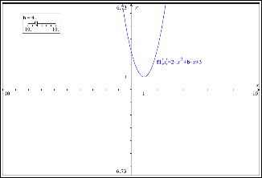
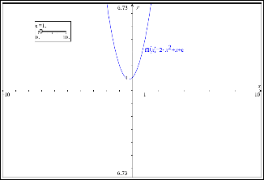

I also wanted to see what happened whenever the parabola had a vertex at a maximum or when a was a negative number. I let a=-2 and the function became
y=-2x^2 +bx +3. I kept the same slider and looked at the graph whenever b=0, b=5, b=-5. As you can see below, when b was positive and becoming larger the graph shifted up and to the left or positive side of the graph. When b was negative and the absolute value of b was becoming larger it shifted up and to the left or negative side of the graph. This is completely opposite than what happens when a is positive.

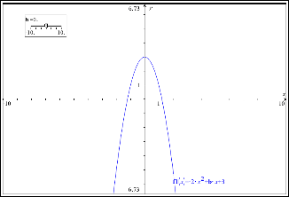

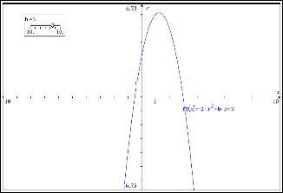

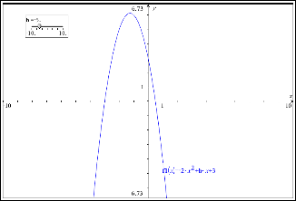

What I concluded from these graphs was that the b value when a is positive shifts the graph down and to the left when the b value is positive and down and to the right when the b value is negative. When a is negative the b value shifts the graph up and to the right when the b value is positive and up and to the left when the b value is negative.
Slider exploration for c: For the exploration for variable c I followed the same procedures as I did before. I let a=2, b=1, and I created a slider for c. The function read y=2x^2 +x +c. I adjusted the settings for the slider by letting the variable be c and making the minimum set to -10, maximum set to 10, and step size to 1. I let c=0 first to see where the graph was.

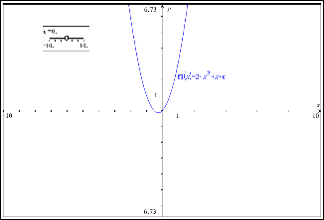

Next I let c=4 and c=6. The graph simply shifted up 4 units and then 6 units. So as c gets larger the higher up the graph gets shifted.
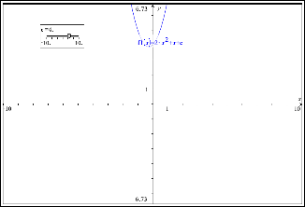

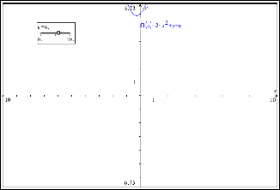

Then I let c=-2 and c=-8. The graph shifted down 2 units and then shifted down 8 units so that the y intercept was at -2 and -8.

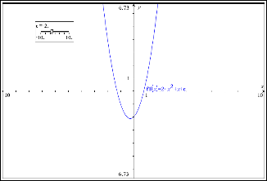

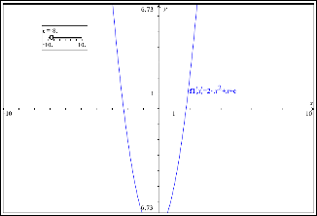

Lastly, I made the a value negative so that the function read y= -2x^2 +x+c. I let c=4 and c=-4. The graph did the same thing it did whenever a was positive. The graph shifted up 4 units when c was 4 and shifted down 4 units when c was -4.

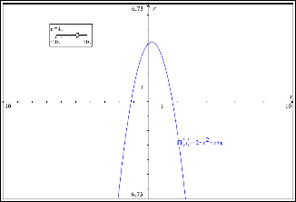

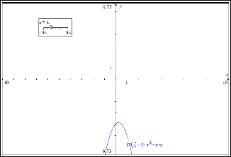

I concluded that the c value is in charge of the y intercept of the graph. It does not matter if the a value is positive or negative in this case. So, when the c value is positive it shifts up and when the c value is negative it shifts down.
Simultaneous exploration Case 1: For case 1 I created a new document in TI Inspire. I chose the graph function and inserted a*x^2 +2*x +3|a={-4,-3,-2,-1,0,1,2,3,4}. I let b=2 and c=3 and the a value varies between {-4,-3,-2,-1,0,1,2,3,4}.
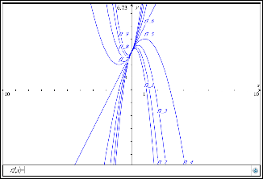

As a varies and b and c are held constant, the graph becomes progressively thinner as the absolute value of a becomes larger. When a is positive and when a is getting larger, the vertex of the graph is located at the minimum of the graph and the graph becomes thinner. When a is negative and when the absolute value of a is getting larger, the vertex of the graph is located at the maximum of the graph and the graph becomes thinner. The common point to all these graphs is at (0,3). This point has to do with the constant c value which is 3. When a=0 the parabola becomes a line. This is because there is no more ax^2 value since a is 0 and now the function reads y=bx+c, which is a linear equation.

Simultaneous exploration Case 2: For case 2 I created a new document in TI Inspire and chose the graphs option. I inserted the equation
1*x^2 +b*x+3|b={−5,−4,−3,−2,−1,0,1,2,3,4}. I let a=1, c=3, and b varied between {−5,−4,−3,−2,−1,0,1,2,3,4}.

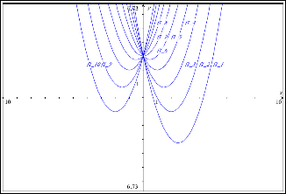

As b varies and a and c remain constant the graph shifts down and to the right or left. When b is positive and becomes larger it shifts down and to the left or the negative side of the graph. When b is negative and the absolute value of b becomes larger the graph shifts down and to the right or positive side of the graph. When we make the a value a negative number the graph acts a little differently. I changed a=1 to a=-1 so that the function read -1*x^2 +b*x+3|b={−5,−4,−3,−2,−1,0,1,2,3,4}.
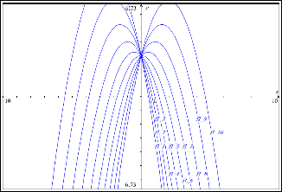

When b is positive and as it becomes larger the graph shifts up and to the right. When b is negative and as the absolute value of b becomes larger the graph shifts up and to the left. This is the opposite of the case when a is positive. The common point for all the graphs is at (0,3). This is because c=3 in the equation. When b=0 the line of symmetry for the parabola is the y-axis.
Simultaneous exploration Case 3: For case 3 I created a new document in TI Inspire and chose the graphs option. I insterted the function
1*x^2 +2*x+c|c={−5,−4,−3,−2,−1,0,1,2,3,4,5}. I let a=1, b=2, and c varied between {5,−4,−3,−2,−1,0,1,2,3,4,5}.
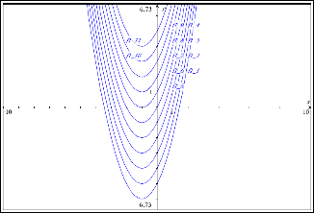

As a and b remain constant and c varies the graph either shifts up and down. When c is positive it shifts up and when c is negative it shifts down. If c was equal to 3 it would shift up 3 units and if c was equal to -3 it would shift down 3 units. The c value has to do with the y intercept of the function. We concluded before that even when a is negative the c value would still shift up when positive and shift down when negative. There is no common point on all these graphs because we do not have a set c value or y intercept. When c=0 it is at its original y intercept, which is at 2. As we make c larger the y intercept will become larger and as we make c smaller the y intercept will become smaller. For example, when c=-1 the y intercept would be at 1. When c=2, the y intercept would be at 4.
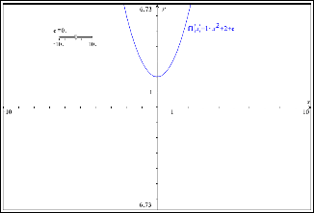
Exploration of graphs of families of quadratic functions with a given property/Roots exploration: For part 2 of this project I opened up a new TI Inspire document and chose graphs. I then graphed the function (x-3)(x-5) which is x^2 -8x +15. The roots or zeroes of this function are at x=3 and x=5.
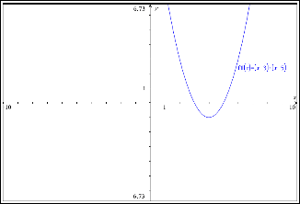

Next, I took this graph and also graphed 2(x-3)(x-5), 3(x-3)(x-5), 4(x-3)(x-5), 5(x-3)(x-5), 6(x-3)(x-5), 7(x-3)(x-5), -1(x-3)(x-5), -2(x-3)(x-5), -3(x-3)(x-5), -4(x-3)(x-5), -5(x-3)(x-5), -6(x-3)(x-5), -7(x-3)(x-5). These 15 graphs came out looking like the graph below.
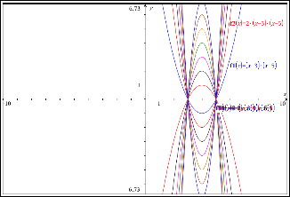

All 15 of these graphs have the same roots at x=3 and x=5. Although all 15 of these functions are different, a greatest common divisor can be factored out of each equation so that we get d(x-3)(x-5) where d is a constant. These 15 graphs all intercept at (3,0) and (5,0). All of these graphs also have different y intercepts. Although their roots are the same, the y intercept of each graph is different. The graphs all stay in the same general area but the thinness of each graph changes and the y intercept of each graph changes. The only thing that stays the same is the axis of symmetry at the vertex and the roots of the graph. The vertex for all of the graphs all have the same x intercept but different y intercepts. The vertex is located at (4,e) where e is a constant. The line for the axis of symmetry of each graph is at x=4. Also, whenever the a term of the function, ax^2 +bx +c, changes the graph either becomes thinner and the vertex is located at the minimum of the graph when a is positive. When a is negative the vertex is located at the maximum of the graph and becomes thinner as the absolute value of a becomes larger.

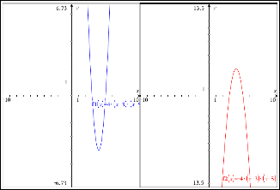

Reflection: TI Inspire is a great program for students and teachers to explore graphs that cannot be seen on a graphing calculator. It allows students to see parabolas on a larger scale and in a way that they can develop a deeper understanding. This activity lets students overlay graphs so that they can compare and contrast what happens whenever a variable is changing. Students are able to interact hands on with this technology to see all the properties of parabolas. With this technology students do not have to worry about drawing a graph perfectly or doing messy calculations that can discourage students. Students are able to accurately examine several different parabolas. This activity is enhanced by TI Inspire and affects students in a positive way.

IDP TPACK TEMPLATE (INSTRUCTIONAL DESIGN PROJECT TEMPLATE)
NAME: ____________ DATE:________________
Content. | Describe: content here. (COMMON CORE STANDARDS)  - CCSS.Math.Content.HSA-SSE.A.1 Interpret expressions that represent a quantity in terms of its context.★  - CCSS.Math.Content.HSA-SSE.A.1a Interpret parts of an expression, such as terms, factors, and coefficients.  - CCSS.Math.Content.HSA-SSE.B.3 Choose and produce an equivalent form of an expression to reveal and explain properties of the quantity represented by the expression.★  - CCSS.Math.Content.HSA-SSE.B.3a Factor a quadratic expression to reveal the zeros of the function it defines.  - CCSS.Math.Content.HSA-CED.A.2 Create equations in two or more variables to represent relationships between quantities; graph equations on coordinate axes with labels and scales.  - CCSS.Math.Content.HSA-REI.D.10 Understand that the graph of an equation in two variables is the set of all its solutions plotted in the coordinate plane, often forming a curve (which could be a line).  - CCSS.Math.Content.HSF-IF.B.4 For a function that models a relationship between two quantities, interpret key features of graphs and tables in terms of the quantities, and sketch graphs showing key features given a verbal description of the relationship. Key features include: intercepts; intervals where the function is increasing, decreasing, positive, or negative; relative maximums and minimums; symmetries; end behavior; and periodicity.★  - CCSS.Math.Content.HSF-IF.C.7 Graph functions expressed symbolically and show key features of the graph, by hand in simple cases and using technology for more complicated cases.★  - CCSS.Math.Content.HSF-IF.C.7a Graph linear and quadratic functions and show intercepts, maxima, and minima.  - CCSS.Math.Content.HSF-IF.C.7c Graph polynomial functions, identifying zeros when suitable factorizations are available, and showing end behavior.  - CCSS.Math.Content.HSF-IF.C.8 Write a function defined by an expression in different but equivalent forms to reveal and explain different properties of the function.  - CCSS.Math.Content.HSF-IF.C.8a Use the process of factoring and completing the square in a quadratic function to show zeros, extreme values, and symmetry of the graph, and interpret these in terms of a context.  - CCSS.Math.Content.HSF-IF.C.9 Compare properties of two functions each represented in a different way (algebraically, graphically, numerically in tables, or by verbal descriptions). For example, given a graph of one quadratic function and an algebraic expression for another, say which has the larger maximum.  Describe: Standards of mathematical Practice  Make sense of problems and persevere in solving them  Reason abstractly and quantitatively  Model with Mathematics  Use appropriate tools strategically  Attend to precision  Look for and make use of structure
Pedagogy. Pedagogy includes both what the teacher does and what the student does. It includes where, what, and how learning takes place. It is about what works best for a particular content with the needs of the learner. | 1. Describe instructional strategy (method) appropriate for the content, the learning environment, and students. This is what the teacher will plan and implement.  The teacher will begin the class by asking students to think of parabolas in every day life. Give the students about 5 minutes to discuss the topic. Have students share their knowledge of parabolas and examples of parabolas in every day life. Then show students using a computer and doc cam show students examples of parabolas. The teacher can find this by simply searching “parabolas in the real world” in a search engine. Next talk about the properties of parabolas. How they have a maximum, minimum, vertex, axis of symmetry, roots, etc. Next, give the students the formula for a parabola/quadratic function (ax^2 +bx+c). Ask the students what do they think happens when a is positive and when a is negative. Do this also for b and c. Ask the students how they find the roots of the function and about factoring. Class discussion should take about 10 minutes on properties of quadratics. Students should have prior knowledge on how to use TI Inspire/Geogebra (both soft wares work fine for this activity). Show the students how to type in the equation for a quadratic correctly in the graphs section. Next, show the students how to create a slider and how to choose the appropriate variable to vary using the slider. The teacher should show these students these things using the laptop located in the classroom and the doc cam. Examine graphs for the parabola  y=ax^2 +bx+c for different values of a,b, and c (a,b,c can be any rational numbers). Use sliders for this exploration. Pay attention to movement of the parabola as you vary each parameter. Describe how parameters a,b, and c affects the graph of the function as you are adjusting the slider. (Teacher should have taken previously screen shots of each graph before teaching the lesson. The teacher can give these screen shot as a handout to their students). Show students what happens when a varies and b and c stay constant. Show properties for when a is positive and a is negative. Show students what happens when b varies, and a and c stay constant on a new document. Show the properties of when a is positive and b is positive and negative. Also, show the properties of when a is negative and b is positive and negative. Show students what happens when c varies and a and b stay constant on another new document. The teacher should show the students what happens as c becomes positive and negative. Discuss each graph and properties of each. This should take 15 to 20 minutes. Next have the students migrate to the computer lab or use the laptops located in the classroom. Have the students work in pairs and explore the following cases:  - Simultaneous exploration  Use the graph app to Create a graph for the different cases below: In each case you are to make at least 6 graphs on the same axes using the given syntax. You are then to answer use your graphs to answer the questions associated with each case. You are to include appropriate screen shots in your answers.  - Case 1: b, c constant a varies: use the syntax,${f\left(x\right)=a*x}^{2}+ b*x+c| a=\{-4,-3,-2,-1, 0,1, 2,3, 4, etc\}$ where b and c can be any constant number such that b and c are not equal.  Questions to answer:  - What happens to the graph as a varies and b and c are held constant  - Is there a common point to all the graphs? What is it?  - What is the significance of the graph where a=0?  - Case 2: a, c constant, b varies: use the syntax ${f\left(x\right)=a*x}^{2}+ b*x+c| b=\{-5,-4, -3, -2, 0, 1, 2, 4, etc\}$. where a and c can be any constant such that a and c are not equal.  Questions to answer:  - What happens to the graph as b varies and a and c are held constant  - Is there a common point to all the graphs? What is it?  - What is the significance of the graph where b=0?  - Case 3: a, b constant, c varies: use the syntax ${f\left(x\right)=a*x}^{2}+ b*x+c| b=\{-5, -4,-3, -2,1, 0,1, 2,3, 4,5 etc\}$. where a and c can be any constant number such that a and c are not equal.  Questions to answer:  - What happens to the graph as c varies and a and b are held constant  - Is there a common point to all the graphs? What is it?  - What is the significance of the graph where c=0?  Have students answer these questions in a word document and give appropriate screen shots to support each answer. Next have students overlay 15 graphs on the same axes with the property that their roots are 3 and 5 respectively. Explore these graphs. Give students a minute to think about this before guiding them on what to do. Have students email the graph to themselves or take a picture with their phone (school guidelines). Then have students answer these questions for homework or finish as classwork.  Questions to answer:  - What do you notice about the roots of all 15 graphs  - What do you notice about the Intercepts of these graphs  - What do you notice about their Intersection points  - What do you notice about the Orientation or Position of the graphs  - Do they have Common points? What can you say about their common points  - What do you notice about the correlation between the orientation of the graphs and the Sign or coefficient of the x^2 term?  - What do you notice about the Locus of the vertex of each of these graphs?  2. Describe what learner will be able to do, say, write, calculate, or solve as the learning objective. This is what the student does.  The student will discuss with their classmates about parabolas in real life. Next the students will listen to the teacher as she shows parabolas in real life on the doc cam. The student will then discuss with their class and their teacher about the properties of quadratics. The student should review maximums, minimums, roots, vertex, axis of symmetry, etc. The student will then pay attention to the teacher as she/he shows students the slider exploration. Students should then have a deep understanding of quadratics and the properties of each variable. Students should then work in pairs to complete the exploration and follow these guidelines:  - Case 1: b, c constant a varies: use the syntax,${f\left(x\right)=a*x}^{2}+ b*x+c| a=\{-4,-3,-2,-1, 0,1, 2,3, 4, etc\}$ where b and c can be any constant number such that b and c are not equal.  Questions to answer:  - What happens to the graph as a varies and b and c are held constant  - Is there a common point to all the graphs? What is it?  - What is the significance of the graph where a=0?  - Case 2: a, c constant, b varies: use the syntax ${f\left(x\right)=a*x}^{2}+ b*x+c| b=\{-5,-4, -3, -2, 0, 1, 2, 4, etc\}$. where a and c can be any constant such that a and c are not equal.  Questions to answer:  - What happens to the graph as b varies and a and c are held constant  - Is there a common point to all the graphs? What is it?  - What is the significance of the graph where b=0?  - Case 3: a, b constant, c varies: use the syntax ${f\left(x\right)=a*x}^{2}+ b*x+c| b=\{-5, -4,-3, -2,1, 0,1, 2,3, 4,5 etc\}$. where a and c can be any constant number such that a and c are not equal.  Questions to answer:  - What happens to the graph as c varies and a and b are held constant  - Is there a common point to all the graphs? What is it?  - What is the significance of the graph where c=0?  Then students will overlay 15 graphs on the same axes with property that their roots are 3 and 5 respectively. These students should think about this with their partner before asking the teacher questions about what this means. Next the student will explore these graphs and either email the screen shot or take a picture of the graph so that they can compete the rest of their homework/classwork  Questions to answer:  - What do you notice about the roots of all 15 graphs  - What do you notice about the Intercepts of these graphs  - What do you notice about their Intersection points  - What do you notice about the Orientation or Position of the graphs  - Do they have Common points? What can you say about their common points  - What do you notice about the correlation between the orientation of the graphs and the Sign or coefficient of the x^2 term?  What do you notice about the Locus of the vertex of each of these graphs?  3. Describe how creative thinking--or, critical thinking, --or innovative problem solving is reflected in the content.  Creative thinking is very important in this lesson. Students must have a deep understanding of parabolas and the properties of quadratics. Students need to use technology to answer questions for classwork. Students are working hands on with parabolas. The students are able to think about parabolas without having to hand draw each one. This activity allows the student to see several parabolas at once so that they can interpret the properties of each variable in a quadratic function.
Technology. | - Describe the technology  HS.TT.1 Use technology and other resources for assigned tasks  HS.TT.1.2 Use appropriate technology tools and other resources to organize information  HS.TT.1.3 Use appropriates technology tools and other resources to design products to share information with others.  The technology used is TI Inspire. The lesson can also be completed using Geogebra. TI Inspire allows students and teachers to see several graphs at once, add sliders, do mathematical computations, trace objects, etc.  - Describe how the technology enhances the lesson, transforms content, and/or supports pedagogy.  The technology enhances the lesson by allowing students to see parabolas on a large scale so that they can compare the properties each variable of a quadratic function. TI Inspire transforms the content by allowing students to get out of the regular lecture classroom and work with an interactive technology that allows them to work hands on with parabolas. It supports pedagogy by allowing the teacher to show the students parabolas in a more detailed way. It gives the teacher a chance to show the students and have the students interact with parabolas on a deeper level.  - Describe how the technology affects student’s thinking processes.  TI Inspire affects the student’s thinking process by allowing them to work hands on with parabolas. It gives students a chance to have a deeper understanding of parabolas on a level that pencil and paper cannot touch. It allows students to tweak the properties of parabolas and quadratic functions so that they can actually see and understand
Reflect—how did the lesson activity fit the content? How did the technology enhance both the content and the lesson activity? | Reflection  The lesson activity fit the content for various common core standards. This activity could be used for Math 1 and Math 11 and even Math 111. To make this interesting to higher-level math students, the students could examine the graphs of parabolas when the variables in the function are not integers. The technology enhanced the lesson activity by having students’ work hands on with parabolas and not having to deal with the messiness of pencil and paper. The technology allows students to see parabolas on a large scale to examine their properties and to understand all of the content.

North Carolina 6-Point Lesson Plan

Subject: High School Mathematics (Math 1,2, or 3) | Topic: Exploration of the effect of parameter changes on the graph of a parabola
Teacher: Elizabeth Springer | Date: 12/4/13

- NC Standard Course of Study Objective:
- CCSS.Math.Content.HSA-SSE.A.1 Interpret expressions that represent a quantity in terms of its context.★
  - CCSS.Math.Content.HSA-SSE.A.1a Interpret parts of an expression, such as terms, factors, and coefficients.
- CCSS.Math.Content.HSA-SSE.B.3 Choose and produce an equivalent form of an expression to reveal and explain properties of the quantity represented by the expression.★
  - CCSS.Math.Content.HSA-SSE.B.3a Factor a quadratic expression to reveal the zeros of the function it defines.
- CCSS.Math.Content.HSA-CED.A.2 Create equations in two or more variables to represent relationships between quantities; graph equations on coordinate axes with labels and scales.
- CCSS.Math.Content.HSA-REI.D.10 Understand that the graph of an equation in two variables is the set of all its solutions plotted in the coordinate plane, often forming a curve (which could be a line).
- CCSS.Math.Content.HSF-IF.B.4 For a function that models a relationship between two quantities, interpret key features of graphs and tables in terms of the quantities, and sketch graphs showing key features given a verbal description of the relationship. Key features include: intercepts; intervals where the function is increasing, decreasing, positive, or negative; relative maximums and minimums; symmetries; end behavior; and periodicity.★
- CCSS.Math.Content.HSF-IF.C.7 Graph functions expressed symbolically and show key features of the graph, by hand in simple cases and using technology for more complicated cases.★
  - CCSS.Math.Content.HSF-IF.C.7a Graph linear and quadratic functions and show intercepts, maxima, and minima.
- CCSS.Math.Content.HSF-IF.C.7c Graph polynomial functions, identifying zeros when suitable factorizations are available, and showing end behavior.
  - CCSS.Math.Content.HSF-IF.C.8 Write a function defined by an expression in different but equivalent forms to reveal and explain different properties of the function.
    - CCSS.Math.Content.HSF-IF.C.8a Use the process of factoring and completing the square in a quadratic function to show zeros, extreme values, and symmetry of the graph, and interpret these in terms of a context.

- CCSS.Math.Content.HSF-IF.C.9 Compare properties of two functions each represented in a different way (algebraically, graphically, numerically in tables, or by verbal descriptions). For example, given a graph of one quadratic function and an algebraic expression for another, say which has the larger maximum.

Activity | Description of Activities and Setting | Materials and Time
I. Focus and Review (Establish prior knowledge) | Students should have prior knowledge on how to use TI Inspire/Geogebra and should be comfortable with parabolas, roots, intercepts, intersections, vertex, maximum, minimum, and factoring. When entering class have students discuss parabolas in the real world and then discuss with the whole class. Teacher should then use their laptop and doc cam to show examples of parabolas in the real world. | 10-15 minutes.  Lap top and  Doc cam.
II. Statement (Inform student of objectives) | Exploration of the effect of parameter changes on the graph of a parabola. Introduce TI Inspire to the students and show them basic properties of creating a graph, inputting a quadratic equation, and how to create a slider and adjust the properties. | 5-10 minutes
III. Teacher Input (Present tasks, information, and guidance) | Examine graphs for the parabola y= ax^2 +bx+c for different values of a, b and c (a, b, c can be any rational numbers). Use sliders for this exploration. Pay attention to the movement of the parabola as you vary each parameter. Describe how parameters a, b, and c affects the graph of the function as you are adjusting the slider. Teacher should have previously taken appropriate screen shots to show the students and hand them out on a worksheet or share with students using drop box or Google docs. Show students what happens when a varies and b and c stay constant. Show properties for when a is positive and a is negative. Show students what happens when b varies, and a and c stay constant on a new document. Show the properties of when a is positive and b is positive and negative. Also, show the properties of when a is negative and b is positive and negative. Show students what happens when c varies and a and b stay constant on another new document. The teacher should show the students what happens as c becomes positive and negative. Discuss each graph and properties of each | 20 minutes.  Graphing calculators  Laptop  Doc cam.
IV. Guided Practice (Elicit performance, provide assessment and feedback) | Have students use lap tops either in the classroom or in a computer lab and work in pairs to follow directions to the following:  - Simultaneous exploration  Use the graph app to Create a graph for the different cases below: In each case you are to make at least 6 graphs on the same axes using the given syntax. You are then to answer use your graphs to answer the questions associated with each case. You are to include appropriate screen shots in your answers.  - Case 1: b, c constant a varies: use the syntax,${f\left(x\right)=a*x}^{2}+ b*x+c| a=\{-4,-3,-2,1, 0,1, 2,3, 4, etc\}$ where b and c can be any constant number such that b and c are not equal.  Questions to answer:  - What happens to the graph as a varies and b and c are held constant  - Is there a common point to all the graphs? What is it?  - What is the significance of the graph where a=0?  - Case 2: a, c constant, b varies: use the syntax ${f\left(x\right)=a*x}^{2}+ b*x+c| b=\{-5,-4, -3, -2, 0, 1, 2, 4, etc\}$. where a and c can be any constant such that a and c are not equal.  Questions to answer:  - What happens to the graph as b varies and a and c are held constant  - Is there a common point to all the graphs? What is it?  - What is the significance of the graph where b=0?  - Case 3: a, b constant, c varies: use the syntax ${f\left(x\right)=a*x}^{2}+ b*x+c| b=\{-5, -4,-3, -2,1, 0,1, 2,3, 4,5 etc\}$. where a and c can be any constant number such that a and c are not equal.  Questions to answer:  - What happens to the graph as c varies and a and b are held constant  - Is there a common point to all the graphs? What is it?  - What is the significance of the graph where c=0? | 30-40 minutes  lap tops  graphing calculators  pencil  paper
V. Independent Practice -- Seatwork and Homework (Retention and transfer) | Have students explore the roots of a quadratic function with a given property. Have students overlay 15 graphs on the same axes with the property that their roots are 3 and 5 respectively. Explore these graphs. Have students take pictures/email/etc. so that they can answer the following questions for classwork or finish for homework.  Questions to answer:  - What do you notice about the roots of all 15 graphs  - What do you notice about the Intercepts of these graphs  - What do you notice about their Intersection points  - What do you notice about the Orientation or Position of the graphs  - Do they have Common points? What can you say about their common points  - What do you notice about the correlation between the orientation of the graphs and the Sign or coefficient of the x^2 term?  - What do you notice about the Locus of the vertex of each of these graphs? | Rest of class time  Pencil  Paper  Computer  phone
VI. Closure (Plan for maintenance) | Students should have a deep understanding of parabolas after this lesson. Next class have students try to tweak a graph using TI Inspire so that it matches up with a picture of a real world parabola.

