Statement of Exploration:
Two brothers are part of an expedition and they have discovered a new island. From the sky they notice that the island is shaped like an irregular convex quadrilateral. They are not sure of the actual dimensions of the island, but they want to determine a way that they can fairly divide the island between the two of them.
The older brother suggests that they divide the land along one diagonal. Then, each can have one triangular part. He states that since this method creates two triangles and each will receive one of the two triangles that it is fair.

Introduction to Mathematical Exploration: Finding new land is very possible considering the Earth’s size. Imagining discovering new land is not only good for a students motivation to succeed, but for understanding how to measure land in the correct ways. A student has to be presise in measurements if they wanted to profit from the new found land. Given the thesis above, the students need to put themselves in the two brothers’ shoes. They need to find a correct way in order to distribute the land equally. The first observation will be to decide if the older brother is right using Sketchpad. Would dividing the land along one diagonal, creating two triangles, would the two triangles be equal? Next, for the second observation the students will need to take other shapes into prospective. They will need to construct a Rhombus, Kite, Trapezoid, and Rectangle and test to see that constructing one diagonal creates two equal triangles. They will do this by using Sketchpad. Thirdly, the students will create their own method of dividing a piece of land into two equal parts. They can use any shape of their choice. Then the students will consider many different methods by using sketchpad. Lastly, the students will consider the younger brother’s thesis. The younger brother imposes that if they were to create two diagonals, making four triangles, that when you take the product of the two non ajacent triangles, that the two products are equal. After considering this proposition, the students will need to test to see if this works for a Rhombus, Kite, Trapezoid, and Rectangle. This is all done using sketchpad. In conclusion, students will discuss the properties of quadrilaterals and the real life importance of separating land equally for the two brothers.
Observation 1: I opened up sketchpad and constructed a quadrilateral (ABCD) with length AB= 4.27 cm, BC= 8.45 cm, CD= 4.5 cm, and AD= 7.26 cm. From the definition of an irregular quadrilateral, we know that the quadrilateral (ABCD) is irregular. Next, I created a diagonal AC, which I made a different color so that the viewer could see the distinction. I next constructed segments so that I could construct two triangles (ABC) and (CDA). I then colored in the triangle interiors in two separate colors so that one could see the differnce between the older brother’s land and the younger brother’s land. I next found the area of the two triangles. Triangle (ABC) had an area of 16.37 cm squared and triangle (CDA) had an area of 11.31 cm squares. As we can detect 16.37 is not equal to 11.31. So the older brother’s idea about splitting the land, is not true.
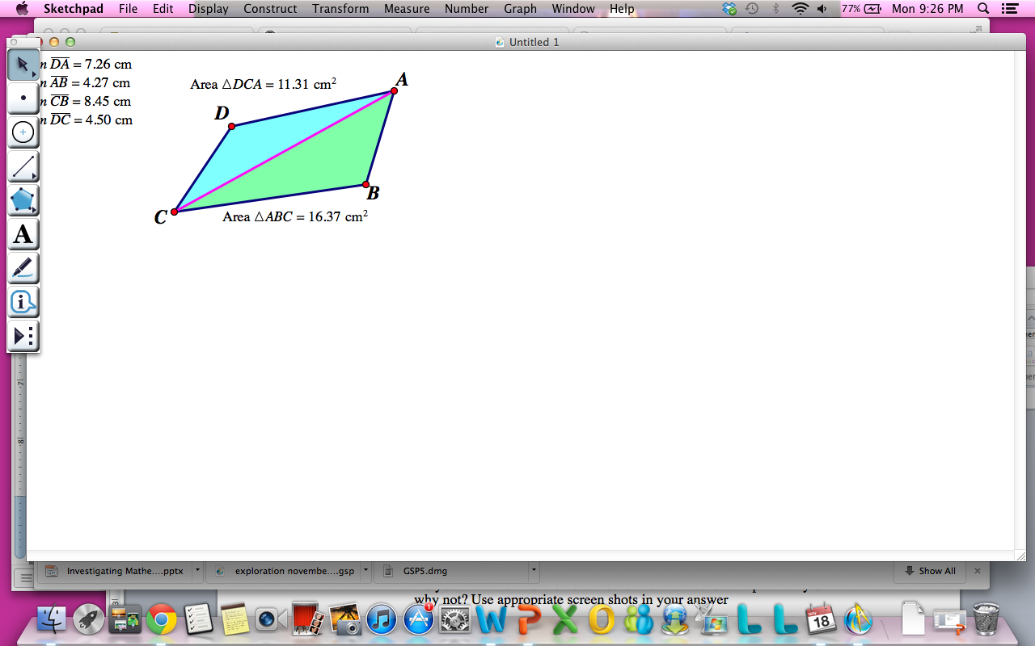
Observation 2: Next, I constructed a Rhombus so that I could see if the older brother’s idea would work for this particular shape. I constructed one side using sketchpad. Then I high lighted the segment and rotated it by 80 degrees. Then I rotated that segment by 100 degrees, and rotated that segment by 80 degrees. Therefore the shape had four equal sides and opposite angles equal. Next I constructed two diagonals to show that the intersection of the diagonals create four right angles. This defines a rhombus. Next I copied and pasted the same rhombus and I hid the diagonals so that I had a plain rhombus to work with. I constructed one segment, just like the brothers wanted to do with their irregular quadrilateral. This made two triangles. I created two different colored triangle interiors and found the two triangle areas. The areas were both 26.64 cm squared. Therefore, the older brother’s method works for a rhombus.
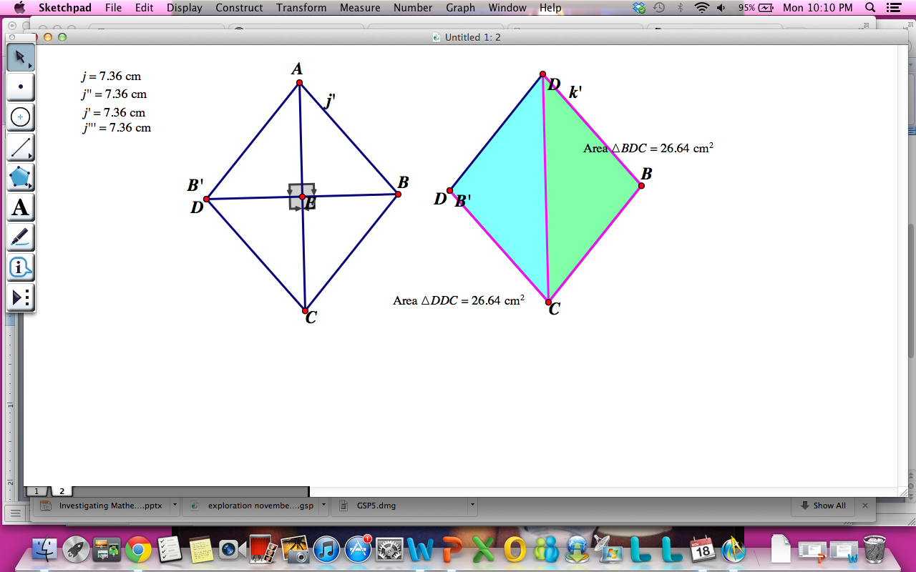
Next, I constructed a kite. A kites properties are defined by having two pairs of adjacent sides equal in length. A kite has one pair of opposite angles equal to eachother and the diagonals create right angles. I first created a kite by drawing one segment and rotating it by a set degree of 70. I then connected the bottom two points, creating a triangle. I then clicked on the top vertex and bottom of the triangle and constructed a perpendicular line. On this line I picked a point and then created segments from this point to the points E and E’ of the triangle. I then hid the perpendicular line and other lines I did not need and constructed the two diagonals. We can see that the two diagonals create right angles. The two ajacent lengths of the triangle are equal with the top two segments equal to 6.33 cm and the bottom two segments equal to 9.67. We can also see that one pair of opposite angles are equal to 122.95 degrees and the two other angles are 70 degrees and 44.10 degrees. Therefore, my kite satisfies the kite defintion. I then copied and pasted twice so that I had two other congruent kites. I created a horizontal diagonal on one and a vertical diagonal on the other. After I constructed triangle interiors, we can see that the kite with the horizontal diagonal did not create two triangles of equal area. These areas were 18.82 and 32.53 cm squared. The kite with the vertical diagonal did create two triangles equal in area. The two areas were both equal to 25.68 cm squared.
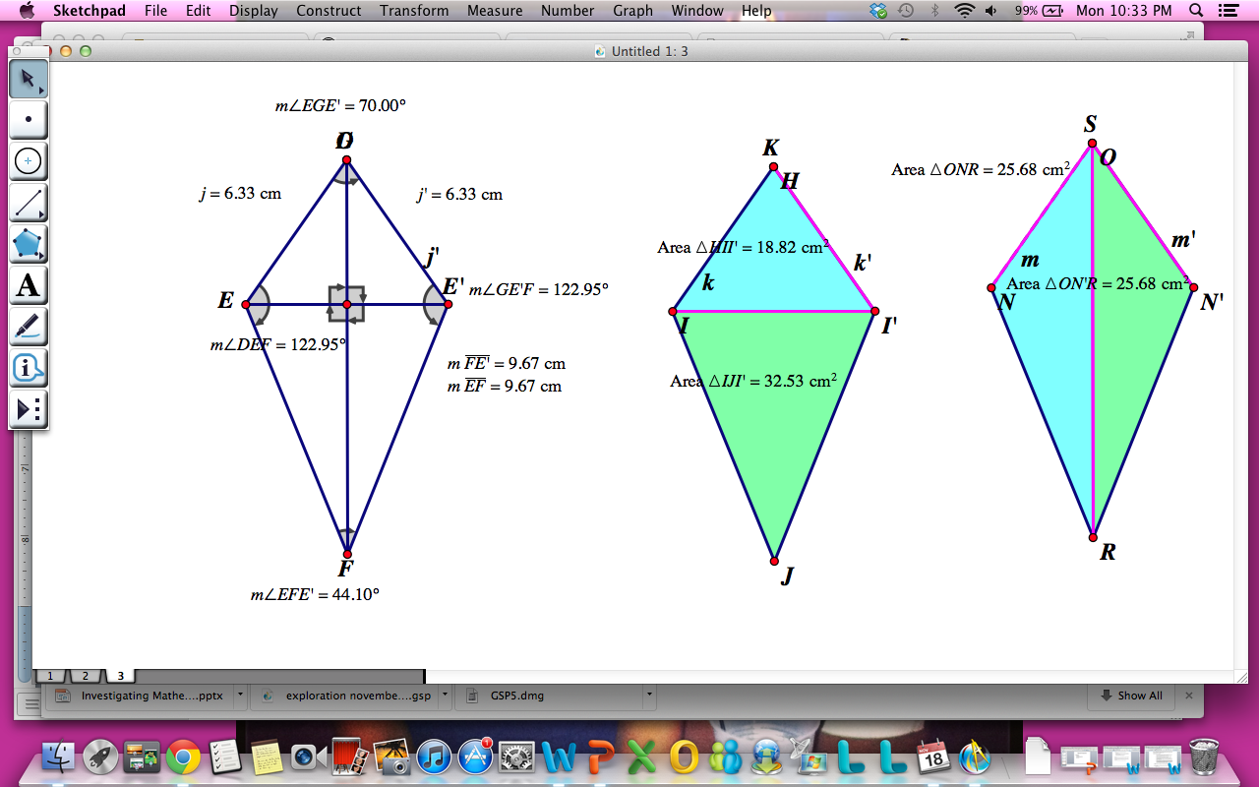
Next, I wanted to look at a Trapezoid. A trapezoid has two bases that are parallel to eachother, but not equal. Then it has two sides equal to eachother. To construct a trapezoid I constructed a segment and then created a perpendicular line and a parallel line to the segment. Then from the parallel line I created a segment on the outside of the rectangle and measured its length. Then I constructed the same segment with same length on the other side. I next connected the two vertices to create two triangles. Then I hid all the lines and I had my trapezoid. The two bases were not equal in length. Segment JK was 6.84 cm and ID was 14.82. The two other sides were both equal to 7 cm. Then I copied and pasted the same exact trapezoid and hid all the appropriate items to hide. I then constructed a diagonal and created triangle interiors. I then found the area of the two triangles. I found out that these areas were not equal. One triangle was 19.68 cm squared and the other was 42.60 cm squared. So the older brother’s method would not work for a trapezoid.
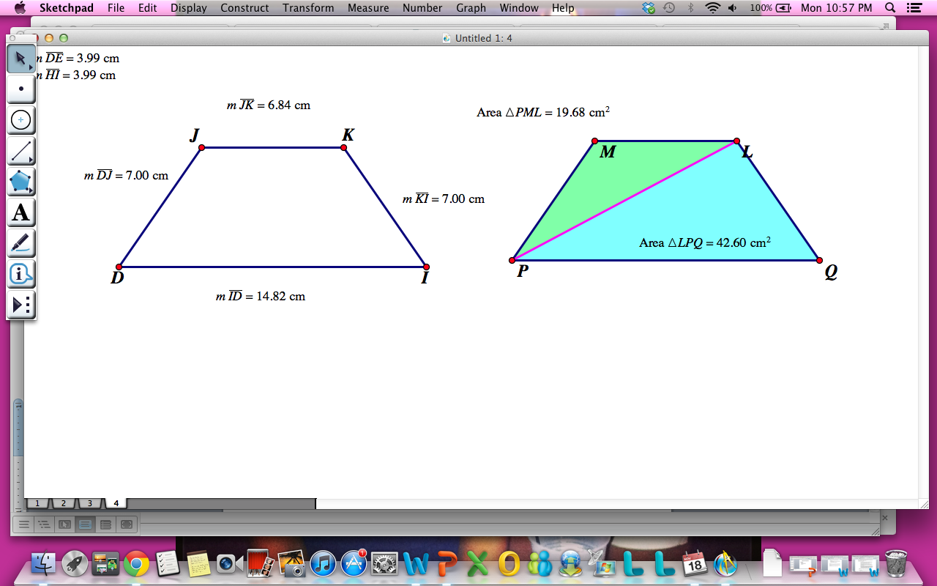
Next, I looked at a rectangle. A rectangles properties tells us that it has two pairs of opposite sides that are equal to eachother and that the angles of a rectangle are all right angles. I constructed the rectangle using Sketchpad by constructing a segment and then constructing perpendicular and parallel lines to the segment and hiding where appropriate. Then we can see that the rectangle forms four right angles. We also see that segment AB and DC are parallel and are both equal to 8.93 cm. Also, segments BC and AD are parallel to eachother and are both equal to 4.73. I then copied and pasted this rectangle and hid the appropriate items. I then created a diagonal and triangle interiors. I then measured the areas. The areas were both equal to 21.10 cm squared. Therefore, the older brother’s idea would work for a rectangle.
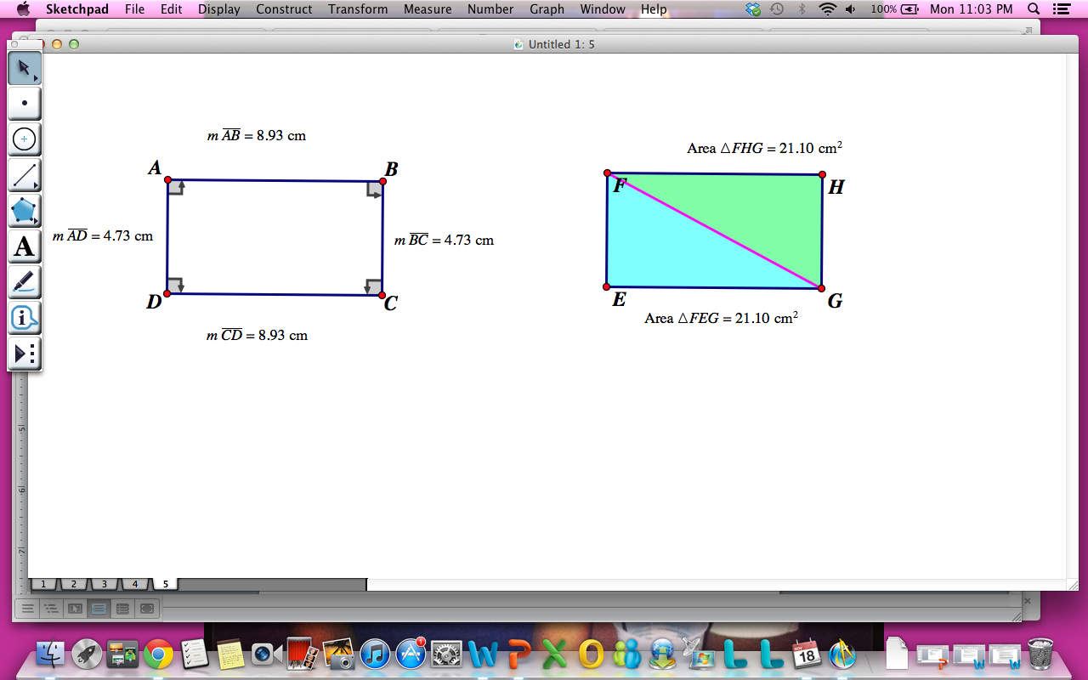
Observation 3: For the third observation I chose a trapezoid. The task for this observation was to choose a shape of my choice and construct a different way to split the shape up so that it has two equal areas. I first found the midpoints of each base. Then I connected the midpoints with a segment. I next colored the two quadrilateral interiors that the segment created. I then found the area of the two interiors. The interiors were both equal to 31.14 cm squared.
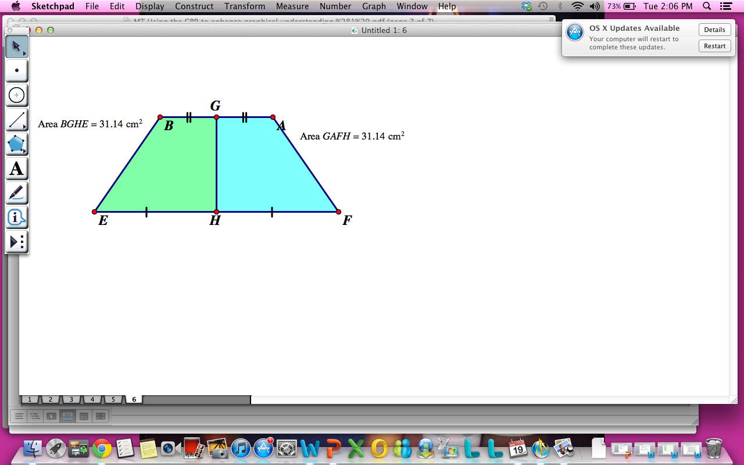
Observation 4: For this observation I used the same irregular quadralateral that I used in the first observation. This time I created two diagonals between the points. I then colored all the four triangle interiors so that I could see the areas better. I then found the area’s of each triangle. Area of triangle HIG was 5.78 cm squared. Area of triangle HIF was 5.54 cm squared. Area of EFI was 8.01 cm squared. Area of triangle GIE was 8.35 cm squared. I then multiplied the two opposite triangles together. For triangle HIG multiplied by triangle EFI I found the area to be 46.27 cm squared. For triangle HIF multiplied by triangle GIE I found the area to be 46.27. So the younger brother’s idea has worked!!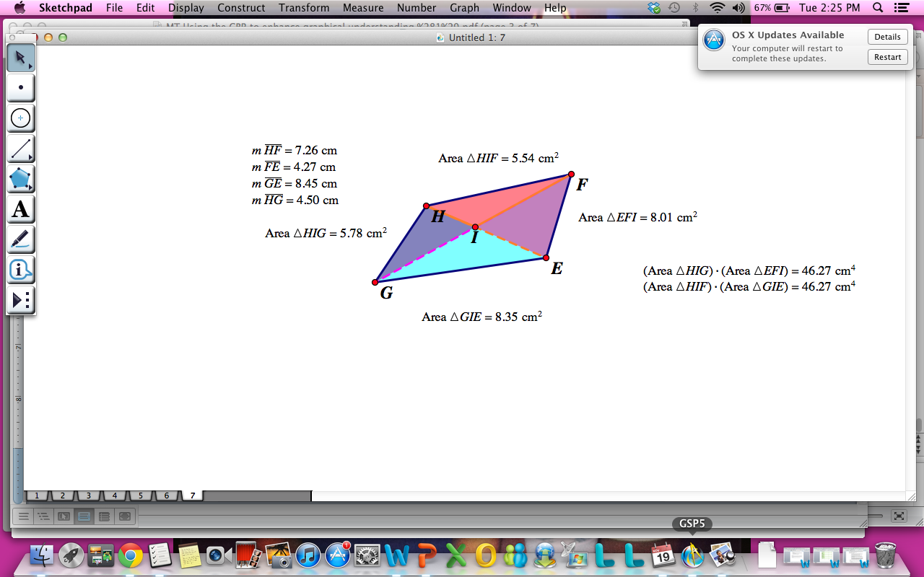
I then used this method on all four of the shapes I used earlier (Rhombus, Kite, Trapezoid, and Rectangle) and it worked for every single one! Thus, the younger brother has thought of a great way to divide land using any kind of land shape.
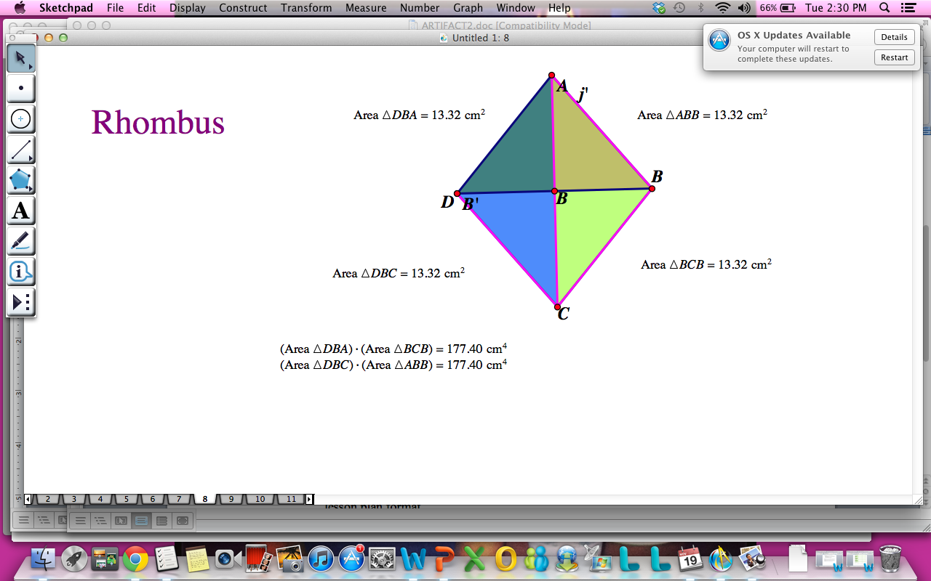
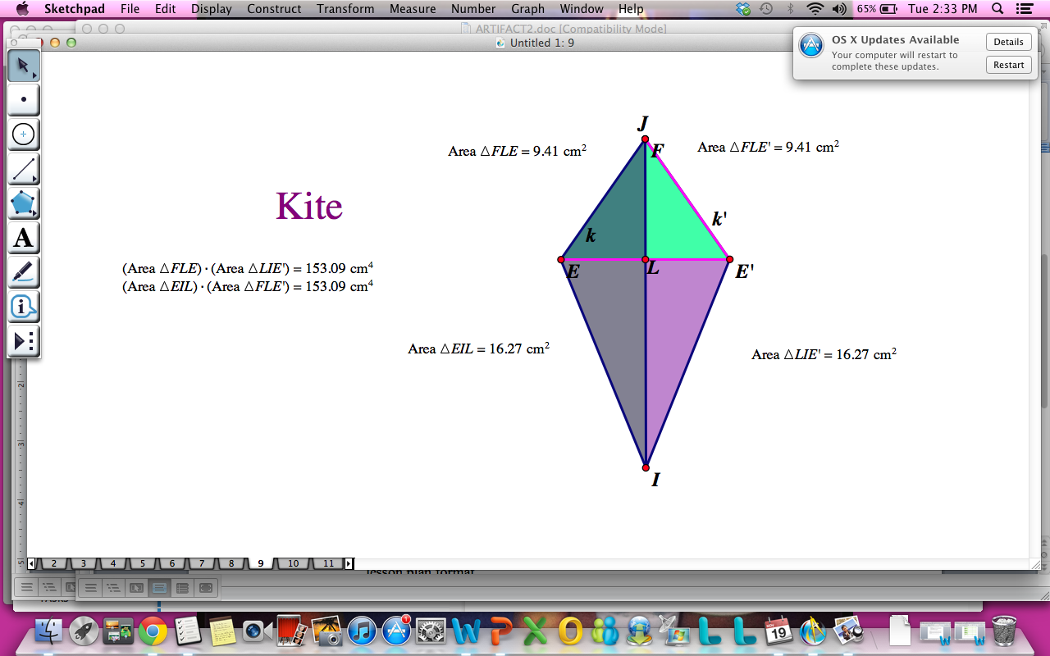
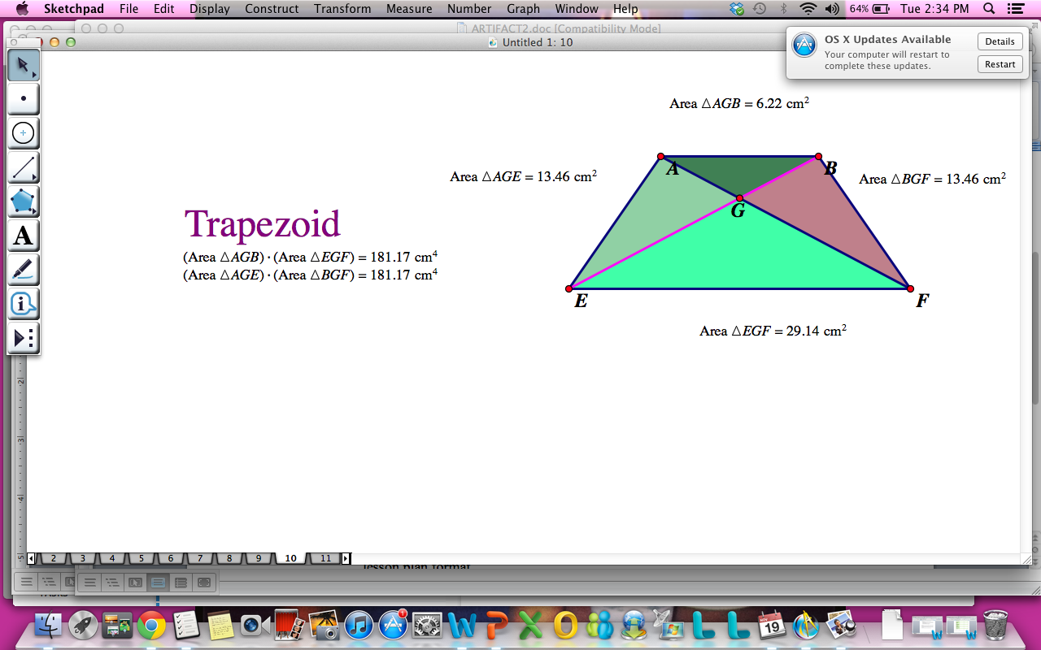
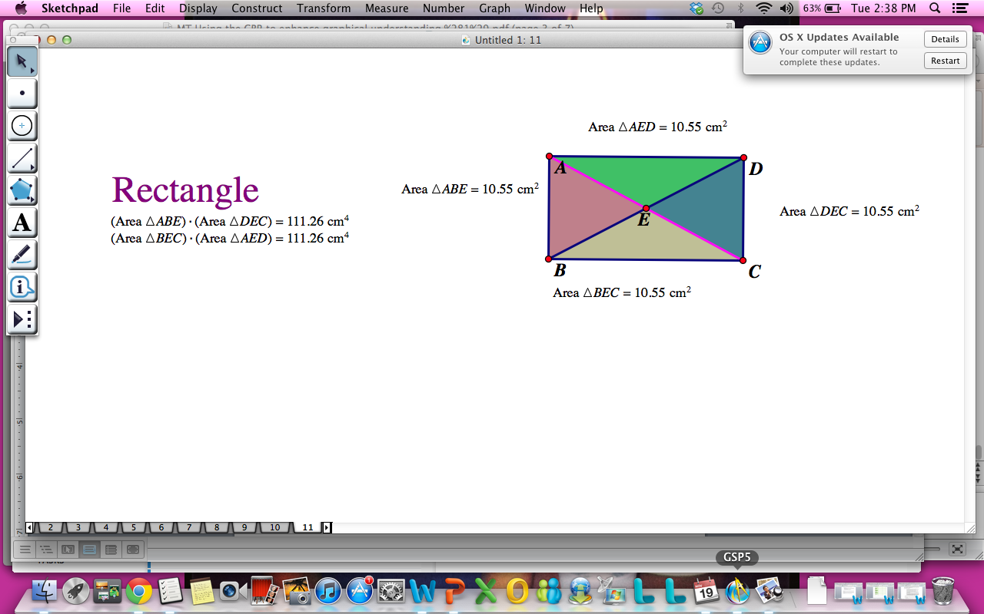

Reflection: The older brother was on the right track for discovering how to separate the irregular shaped island equally, but the younger brother finished this exploration. It is important for the two brothers to divide the land equally because of profits from the island. Lets say that the younger brother got more land than the older brother. Then he would have more land to build on to create houses, stores, schools, churches, ect. Also if the younger brother got more land, then outside viewers of the island might think that he was the one who discovered the island. This leaves out the older brother in any recognition for their discovery. Land is very important these days because we seem to have very little of it due to the growing population. This activity is very beneficial for students in understanding the properties of parallelograms. This activity also allows students to work directly with technology. Technology is very important in the world today because it is our future. Learning and studying mathematics with technology has become the new and improved way to learn and teach. The activity also gives students a real world activity to work with. Many students do not see the importance of math and this activity shows them.

Content. | Describe: content here. (COMMON CORE STANDARDS)  - CCSS.Math.Content.HSG-MG.A.1 Use geometric shapes, their measures, and their properties to describe objects (e.g., modeling a tree trunk or a human torso as a cylinder).★  - CCSS.Math.Content.HSG-MG.A.3 Apply geometric methods to solve design problems (e.g., designing an object or structure to satisfy physical constraints or minimize cost; working with typographic grid systems based on ratios).★  Describe: Standards of mathematical Practice  Make sense of problems and persevere in solving them. Reason abstractly and quantitatively. Construct viable arguments and critique the reasoning of others. Model with mathematics. Use appropriate tools strategically. Attend to precision. Look for and make use of structure.
Pedagogy. Pedagogy includes both what the teacher does and what the student does. It includes where, what, and how learning takes place. It is about what works best for a particular content with the needs of the learner. | 1. Describe instructional strategy (method) appropriate for the content, the learning environment, and students. This is what the teacher will plan and implement.  The teacher will begin the lesson by showing a picture of an island. The teacher will then read the prompt out to the students:  Two brothers are part of an expedition and they have discovered a new island. From the sky they notice that the island is shaped like an irregular convex quadrilateral. They are not sure of the actual dimensions of the island, but they want to determine a way that they can fairly divide the island between the two of them.  The older brother suggests that they divide the land along one diagonal. Then, each can have one triangular part. He states that since this method creates two triangles and each will receive one of the two triangles that it is fair.  The teacher will show the students using a lap top and a doc cam how to construct the irregular quadrilateral. The teacher will describe what an irregular convex quadrilateral is and the properties of it. Next, the teacher will go through the first step of the problem, create a diagonal on the quadrilateral, and find the area’s of the two triangles. The teacher will then prove that this method does not work and have students move on to the computer lab to work on the rest of the problems. The teacher will monitor the computer lab and help students when needed. Assign the students, for homework, to think about and record their thoughts about why it is important for the brothers to split the land equally.  2. Describe what learner will be able to do, say, write, calculate, or solve as the learning objective. This is what the student does.  Students will listen to the teacher’s introduction to their project. They should understand what an irregular shaped island would look like. Students should then take notes on how the teacher constructs the irregular quadrilateral. Students should have prior knowledge to sketchpad, but should still take notes. The students will then go to the computer lab and answer these following questions  1. Do you think the two brothers should use this method? Explain why or why not? Use appropriate screen shots in your answer  2. If the island was of a particular shape, would you suggest using this method? Use appropriate screen shots in your answer.  3. Using sketch pad show another method for dividing the land fairly between the two brothers. Explain your method with appropriate screen shots and justifications.  4. While considering various methods, the younger brother noticed that if you create the diagonals of the quadrilateral, measure the areas of each of the triangular regions created and then multiply the area measures of the two non-adjacent triangles, the products are equal. Is this relationship always true? Explain using appropriate screen shots.  They will do this while using sketchpad, working in pairs. Then the students will think and record for their homework why they think it is important for the brothers to split the land equally.  3. Describe how creative thinking--or, critical thinking, --or innovative problem solving is reflected in the content.  Students need to think about why it is important to split land equally among brothers. They need to relate to the real world on what it means to make a profit with a piece of land, Also, the students need to understand how to actually construct a particular shape and think of ways to divide it equally.
Technology. | - Describe the technology  HS.SI.1.1 Evaluate resources for reliability. (Reliability can be  determined by currency, credibility, authority, etc.  depending on the curriculum topic).  HS.SI.1.2 Evaluate resources for point of view, bias, values, or intent  of information.  HS.SI.1 Evaluate resources needed to  solve a given problem.  HS.SI.1.3 Evaluate content for relevance to the assigned task  HS.RP.1 Design project-based products  that address global problems.  HS.RP.1.1 Design global-awareness project-based products  individually and collaboratively  HS.TT.1 Use technology and other  resources for assigned tasks.  The technology is sketchpad software that is used in Geometry classes. The technology allows a student and teacher actually construct shapes, without a mess, and create demos to increase understanding. The technology is used for geometry purposes but can be used for algebra, also. Sketchpad lets students construct lines and abstract shapes that they may not be able to on paper or be able to imagine in their mind. Sketchpad gives students exact measurments of distances, which helps with eliminating the factor of mistakes.  - Describe how the technology enhances the lesson, transforms content, and/or supports pedagogy.  The technology enhances the lesson by having students actually construct a shape and they can actually see what needs to be done to create equal parts. This transforms the content by having students not having to worry about doing messy calculations, because Sketchpad does it for them. It supports pedagogy by having a tool to show students transformations, reflections, diagonals, and equal area’s without having to become an artist. Sketchpad allows students to work on a real world situation that would be difficult to describe on paper. Also, it gives students a chance to work hands on. This is very helpful for those hands on learners that may not get much attention in the classroom.  - Describe how the technology affects student’s thinking processes.  The technology allows students to block out messy calculations that could get in the way when calculating area. The technology has the students focus on one particular problem, which is how to make an irregular quadrilateral into equal parts. Sketchpad lets students work hands on.
Reflect—how did the lesson activity fit the content? How did the technology enhance both the content and the lesson activity? | Reflection  The lesson activity fit the content in a way that makes it interesting to students. The technology enhances both the content and lesson activity by having students work in real world situations. Also, students are not having to worry about making messy calculations or having to watch the teacher mess with difficult calculations. This can throw students off and make them not want to do the project because they will think it is too hard. I believe this activity is very beneficial way to get the students out of the classroom and working hands on with technology, which is what future mathematics is leading to.

Three part lesson plan:
Common Core State Standards:
- CCSS: CCSS.Math.Content.HSG-MG.A.1 Use geometric shapes, their measures, and their properties to describe objects (e.g., modeling a tree trunk or a human torso as a cylinder).★
- CCSS.Math.Content.HSG-MG.A.3 Apply geometric methods to solve design problems (e.g., designing an object or structure to satisfy physical constraints or minimize cost; working with typographic grid systems based on ratios).★

Before:
- Activate useful prior knowledge.
Students should have prior knowledge of trapezoids, kites, parallelograms, irregular shapes, and rectangles. Students should also have prior knowledge on how to somewhat work Sketchpad so that they can complete their classwork. Students should be able to construct an area and perimeter of each shape and know the properties of each.
- Be certain the problem is understood.
Students should understand the problem at hand:
Two brothers are part of an expedition and they have discovered a new island. From the sky they notice that the island is shaped like an irregular convex quadrilateral. They are not sure of the actual dimensions of the island, but they want to determine a way that they can fairly divide the island between the two of them.
The older brother suggests that they divide the land along one diagonal. Then, each can have one triangular part. He states that since this method creates two triangles and each will receive one of the two triangles that it is fair.
Guided QUESTIONS for exploration
1. Do you think the two brothers should use this method? Explain why or why not? Use appropriate screen shots in your answer

2. If the island was of a particular shape, would you suggest using this method? Use appropriate screen shots in your answer.

3. Using sketch pad show another method for dividing the land fairly between the two brothers. Explain your method with appropriate screen shots and justifications.

4. While considering various methods, the younger brother noticed that if you create the diagonals of the quadrilateral, measure the areas of each of the triangular regions created and then multiply the area measures of the two non-adjacent triangles, the products are equal. Is this relationship always true? Explain using appropriate screen shots.

- Establish clear expectations.
Students should be able to answer all the questions using sketchpad and work well together in pairs.

During:
- Let go! Avoid stepping in front of the struggle.
Students should listen to the teacher and be able to work together in groups.
- Listen carefully.
Listen to instructions: The teacher will begin the lesson by showing a picture of an island. The teacher will then read the prompt out to the students. The teacher will show the students using a lap top and a doc cam how to construct the irregular quadrilateral. The teacher will describe what an irregular convex quadrilateral is and the properties of it. Next, the teacher will go through the first step of the problem, create a diagonal on the quadrilateral, and find the area’s of the two triangles. The teacher will then prove that this method does not work and have students move on to the computer lab to work on the rest of the problems. The teacher will monitor the computer lab and help students when needed. Assign the students, for homework, to think about and record their thoughts about why it is important for the brothers to split the land equally.

- Provide appropriate hints.
The teacher should assist students but should be able to work well in pairs. Students need to think about why it is important to split land equally among the brothers.

- Observe and assess.
The students will be tested by completing homework a homework assignment giving the instructions on how they came to their conclusion to each answer.
Guided QUESTIONS for exploration
1. Do you think the two brothers should use this method? Explain why or why not? Use appropriate screen shots in your answer

2. If the island was of a particular shape, would you suggest using this method? Use appropriate screen shots in your answer.

3. Using sketch pad show another method for dividing the land fairly between the two brothers. Explain your method with appropriate screen shots and justifications.

4. While considering various methods, the younger brother noticed that if you create the diagonals of the quadrilateral, measure the areas of each of the triangular regions created and then multiply the area measures of the two non-adjacent triangles, the products are equal. Is this relationship always true? Explain using appropriate screen shots.

They should also be able to think critically and write down in an efficient way why dividing land is so important.

After:
- Encourage a community of learners.
Have students work in pairs to discuss findings. Also, the students should be prepared for the next class to discuss their homework and the importance of the project.
- Listen! Accept student solutions without evaluation.
Gather students homework the next day that goes into detail about why it is important to divide land and give students participation points for discussion in class.

