Introduction to Mathematical Exploration:
Thrill seeking is very popular among teenagers and there is no better way to do this than by riding roller coasters. In North Carolina alone, we have Carowinds, easy access to Busch Gardens, and Kings Dominion. This is only a few out of many to name. Many students have probably been to one of these amusement parks before, and if not the students have access to the rides online. Personally, my favorite ride is the Griffon at Busch Gardens in Williamsburg, Virginia. When it opened back in 2007 it was the largest and fastest ride at that certain time. The ride begins by inclining on a 45-degree chain lift hill. When it reaches its top height of 205 feet, the ride holds the passengers at a 90-degree angle for 10 seconds and then continues to drop the passengers. At the bottom of the 90-degree drop, the ride reaches its top speed of 71 miles per hour. The ride continues to drop and loop upside down one more time and the ride ends after about three minutes. To complete my mathematical exploration I am going to have students discuss and research their favorite rides they have been on. After a brief discussion I am going to have the students compare other roller coasters data using the Fathom software by using several different types of graphs, tables, and calculations. They will be analyzing the largest drop within the given roller coaster data, height, length, top speed, and type of roller coaster. After the students compare their data of their personal favorite roller coaster to the given data, then the students will make a decision on what their favorite type of roller coaster would be. This will be under the categories hyper coasters, looping-twister, twister, double out and back, terrain-twister, twister, looping-corkscrew, flying Dutchman, and family-tivoli.
Mathematical Exploration:
The first thing that I will do is open up the Fathom software and display the data in a table like this:
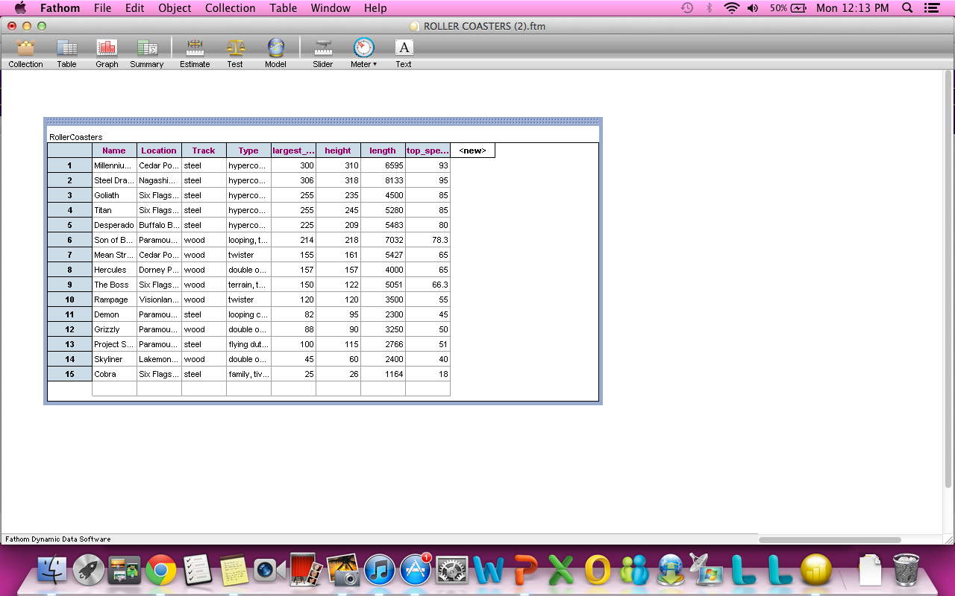

In order to get the data into a table, the student or teacher has to drag the table icon down and then drag the collection data to the table. This shows all the data that is involved with the given roller coasters. As you can see, we have the name of each rollercoaster, where it is from, what type of track it has, and what type of roller coaster it is. We also are given information on the largest drop, height, length, and top speed.
1st experiment: Next, I will find out which roller coaster is the most popular. I simply do this by dragging down the graph icon and dragging the type of roller coaster from the graph to the x-axis of the graph. The information is displayed in a bar graph. We can see that hyper coasters are the most common of all the other roller coasters.
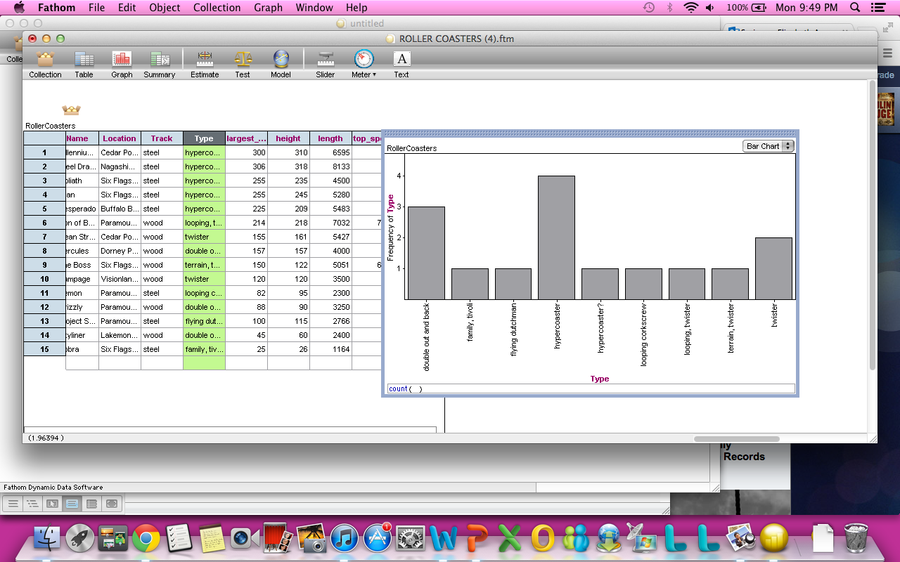
Next, I will take a look at the largest drop. I will drag the graph icon down onto the workable space. Then I will choose an x-axis and a y-axis. Usually, the x-axis is the independent variable and that will be the type of roller coaster. The y-axis will be largest drop. When the graph appears it is in a dot plot. You can plainly see that hyper coasters have the highest drop. By clicking on the highest value of the dot plot, it highlights the data in the table, which shows the roller coaster with the largest drop. The roller coaster with the largest drop is the Steel Dragon located at Nagashima in Spaland, Japan. It is a steel, hyper coaster roller coaster. Next I will drop down the test icon. I will choose “test mean” from the options given. I will continue to drag the largest drop portion of the table into the space provided. After doing this, information pops up with the sample mean, standard deviation, and sample error. All that is required for the student is to look at the sample mean, which is 165.133 feet. Next, I will right click on the graph and go to plot value. From there I will type in mean into the given area. Then preceding the parenthesis I will put largest drop. Then apply. This shows the mean largest drop for each type of roller coasters. The students can use this information to compare to their personal favorite roller coaster. My favorite roller coaster, the Griffon, has a larger drop than the mean of sample roller coasters. The Griffon is however almost 100 feet less than the Steel Dragon with a 306 feet drop.
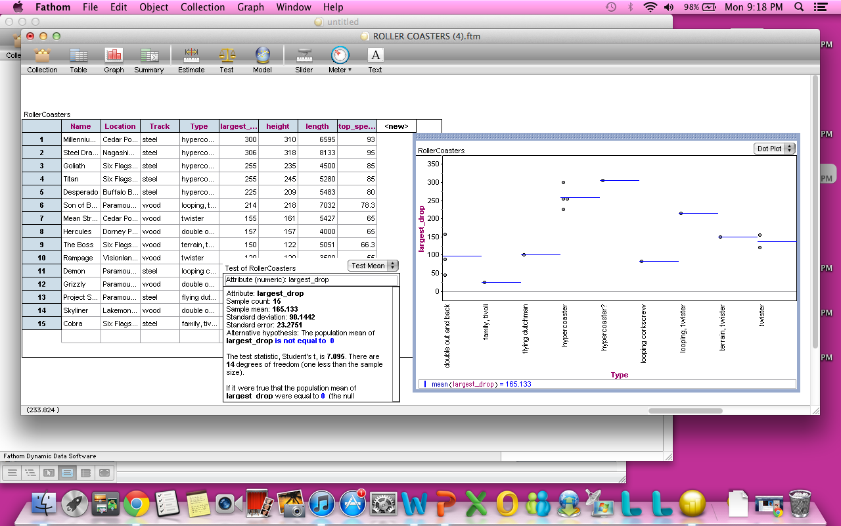

2nd experiment: For the second experiment I will graph the data of the height of the roller coasters. This time I will use a dot plot or box and whisker plot. With this graph we are able to already see the mean of the data and if there are any outliers. Students may not have the knowledge of what an Interquartile Range is at this point, so disregard that information. From the graph we can see that the mean height is 165.4 feet. This is very close to the mean height for the largest drop. This is probably because the roller coasters drop at the highest part of the roller coaster. By clicking on the line in the middle of the box, which is the mean, you can see that several dots are highlighted. This shows several roller coasters that are close to the mean height. The two roller coasters that are closest to the mean are the Mean Streak and the Hercules roller coaster. The mean streak is located at Cedar Point in Sandusky, OH and it is a “twister” roller coaster. Hercules is located at the Dorney Park in Allentown, PA and it is a “double out and back” roller coaster. You can see the two outliers at the end of the graph, which display roller coasters that do not fit within the range. These two roller coasters are the Cobra and the Steel Dragon. The Cobra has the lowest height at 26 feet. It is located at the Six Flags Marina World in Vallejo, CA. It has a steel track and is a family, Tivoli type. The Steel Dragon, which had the largest drop, has a height of 318 feet. The comparison to my favorite roller coaster, the Griffon, is about the same as the comparison with the largest drop. The Griffon has a height of 205 feet, which is higher than the mean but 100 feet less than The Steel Dragon.

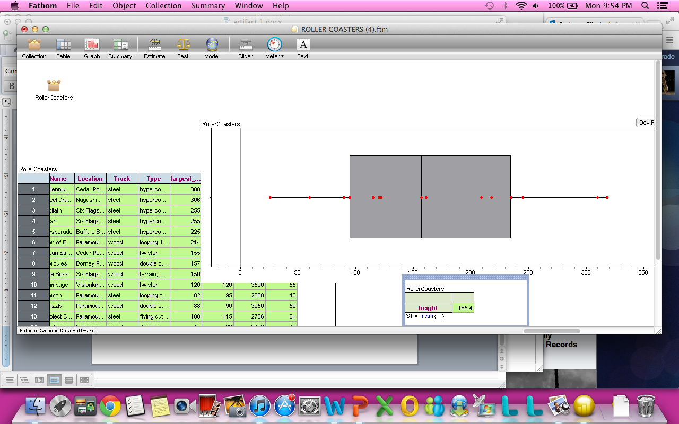
3rd Experiment: For the third experiment I focused on the length of the roller coasters. I constructed a graph just like I have previously with all the others. I dragged the type of roller coaster to the x-axis and the length to the y-axis. I then proceeded to select the line plot graph so that I could see the difference in lengths separated into groups with each type of roller coaster. The graph puts a line in between each type, so that I can clearly see the variance. I then clicked on the length section of the table and dragged it to the graph so that it color codes the line plot. We can now see that the “hot” colors are the higher lengths and the “cool” colors are the lower lengths. We can see that the Steel Dragon has the highest length at 8,133 feet, which is a hyper coaster. The Cobra has the lowest length at 1,164 feet, which is a family-tivoli coaster. The mean of the lengths of the roller coasters is 4, 458.73 feet. Next, I wanted to see if there was a correlation between the height of the roller coaster to the length of the roller coaster. I dragged down the graph to the given space. I then dragged the height to the x-axis and the length to the y-axis. It then shows a scatter plot. We can see before plotting a line of best fit that the points are increasing as x and y increase. To graph a regression line I right clicked the graph. Then I proceeded down to “Least-Squares Line.” Then a line shows up. We can see that there is a positive correlation between the height and length of the roller coasters with 80% accuracy. I can tell this by the equation given at the bottom of the graph: length=19.9height + 1.2e +03; r^2 = .80. If r^2 was given as 1, then it would be a perfect fit. So, in conclusion as the height increases on the roller coasters the length of the ride also increases. In comparison to my favorite roller coaster, the Griffon, the length is 3,108 feet, which is 5,025 feet less than the longest roller coaster, Steel Dragon. The Griffon is 1,944 feet longer than the shortest roller coaster, The Cobra. This time the Griffon is under the mean length by 1,350.73 feet.
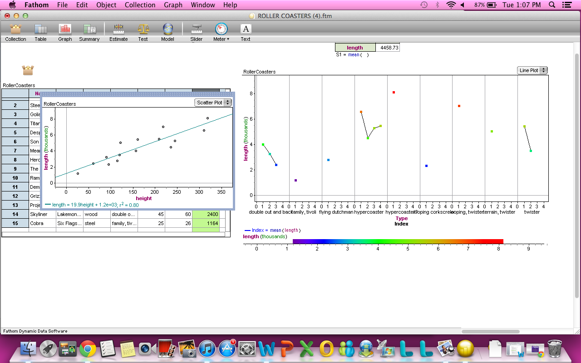

4th experiment: For the fourth experiment I analyzed the top speed of each roller coaster. By constructing a dot plot with type of roller coaster as the x-axis and top speed as the y-axis we can see that the hyper coasters still have the top speed. I also created another graph comparing the largest drop (x-axis) and the top speed (y-axis) and found the Least-Squares line. The correlation was positive just as it was with the length and height from the third experiment. The equation was top speed = 0.236 largest drop +25.7; r^2 = 0.96. This time, the r^2 was closer to 1. This means that the line of best fit is more accurate. The top speed goes to the Steel Dragon, once again, with 95 miles per hour. The lowest speed goes to the Cobra, once again, with 18 miles per hour. The mean of the speeds is 64.7733 miles per hour. My favorite roller coaster, the Griffon, has a top speed of 71 miles per hour. The Griffon is 24 miles per hour slower than the Steel Dragon, 53 miles per hour faster than the Cobra, and 6.2267 miles per hour faster than the mean of the top speeds. This time my favorite roller coaster is higher than the mean, but not by much.
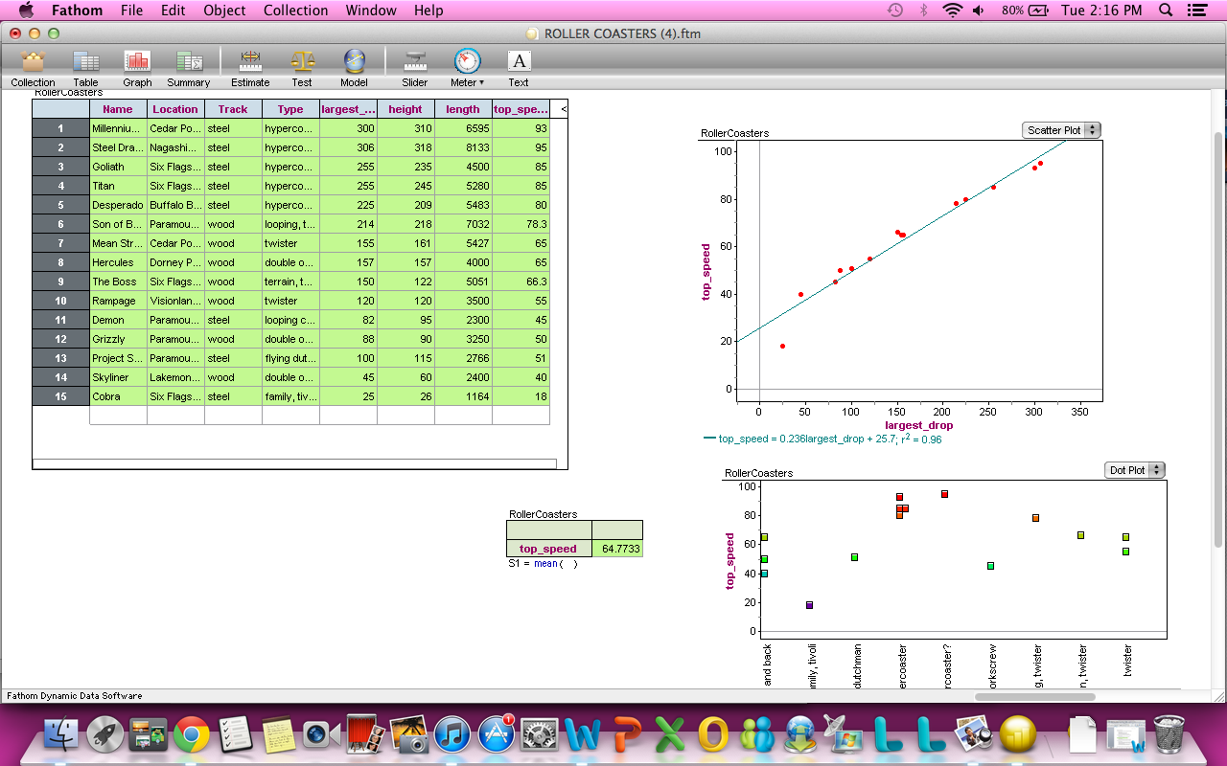
In conclusion: I have gathered up enough information to make a decision on what type of roller coaster I would rather ride. Personally, I like the fast, high, crazy roller coasters so I would like to ride a hyper coaster based on the data. I know that a hyper coaster is guaranteed in this sample to have a high drop, height, length, and speed. When I compare these given hyper coasters to the Griffon I have came to the conclusion that my favorite roller coaster is not the “best” out there.

IDP TPACK TEMPLATE (INSTRUCTIONAL DESIGN PROJECT TEMPLATE)
NAME: __Elizabeth Springer__________ DATE:__11/5/13______________

Content. | Describe: content here. (COMMON CORE STANDARDS)  S-ID.1 Represent data with plots on the real number line (dot plots, histograms, and box plots).  S-ID.2 Use statistics appropriate to the shape of the data distribution to compare center (median, mean) and spread (interquartile range, standard deviation) of two or more different data sets.  S-ID.3 Interpret differences in shape, center, and spread in the context of the data sets, accounting for possible effects of extreme data points (outliers).  S-ID.8 Compute (using technology) and interpret the correlation coefficient of a linear fit  Describe: Standards of mathematical Practice  2. Reason abstractly and quantitatively  3. Construct viable arguments and critique the reasoning of others.  4. Model with Mathematics.  5. Use appropriate tools strategically.  6.Attend to precision
Pedagogy. Pedagogy includes both what the teacher does and what the student does. It includes where, what, and how learning takes place. It is about what works best for a particular content with the needs of the learner. | 1. Describe instructional strategy (method) appropriate for the content, the learning environment, and students. This is what the teacher will plan and implement.  - The teacher will have previously, the day before, asked the students for homework, or during a class visit to the computer lab, to research their favorite roller coaster they have ever been on. If a student has not ever been on a roller coaster then have the student research a roller coaster they would like to ride or are to afraid to ride. They would need to find the name of the roller coaster, location, track type, roller coaster type, largest drop of the ride, height, length, and top speed. The teacher will begin the current lesson by asking the students to locate their research and split up into groups of two to talk about their findings.  - Next, the teacher will pass out his/her findings on their favorite roller coaster and introduce the Fathom software. The teacher will have the roller coaster collection already available on Fathom. Then the teacher will show the students how to drag a table down onto the given space and drag the collection data to the table. The data then will be available in the table.  - The teacher will then ask the students to read the information off of the table, preferably 15 volunteers, and discuss each roller coaster. Next the teacher will pass out the worksheet given for this activity. The activity is asking the students to use Fathom to make a decision on what their favorite type of roller coaster would be under the given criteria. The teacher will then show students how to do this. The teacher will drag the graph option down onto the given space and then drag the column of “type of roller coaster” to the x-axis. A bar chart should appear and students will see that hyper coasters are the most common between this given sample. Explain to the students how a sample is different than a population.  - Next the teacher will create a graph with the “type of roller coaster” as the x-axis and the “largest drop” as the y-axis. Talk about the graph asking students question about the mean, maximum, and minimum. Record all of the information. Then drop down the summary box and drag the “largest drop” onto the box. This will show the mean.  - After showing the “largest drop” have students work independently in their groups to work on the height. Repeating the same steps as the teacher. Once the students have finished, show the students how to find the regression line. Students may not have previous knowledge of what this is, but information should be given on their worksheet. Open up a graph and drag the “largest drop” onto the x-axis and “height” onto the y-axis. Then right click and select “Least-Squares Line.” This should create a line of best fit. Explain to the students how this is a positive correlation because as the largest drop increases the height increases. Record the equation at the bottom of the graph. Explain to the students how the “r squared” in statistics is the measure of how well a set of data points fit a line or graph. The closer r squared is to 1, the more accurate the graph is.  - Have students finish the worksheet following the same steps as shown in class. Teacher should be walking around asking questions and listening to the groups.  - Finish the class by comparing and analyzing the information recorded on the worksheet to the teacher’s favorite roller coaster.  - For homework ask each student to compare the data they found in their groups to their favorite roller coaster.  2. Describe what learner will be able to do, say, write, calculate, or solve as the learning objective. This is what the student does.  - Students will retrieve their homework from the night before with information on their favorite roller coasters. Students will then separate into groups of 2 and discuss their findings with a partner. After a brief discussion, the students will receive their teacher’s favorite roller coaster findings on a worksheet. Connected to this worksheet will be their activity for the rest of the lesson.  - Students will then participate actively to the teacher as he/she introduces Fathom and the information on roller coasters. They will follow along with the teacher and mimic what the teacher shows in fathom involving tables, graphs, finding the mean, maximum, and height. The students will record the information. Next, the students will work independently in their groups and make assumptions using graphs on the height, just like shown previously. After students complete this task they will discuss their findings with the teacher. As the teacher shows the students how to find the regression line, they will develop and understanding of positive and negative correlation using previous knowledge. They will also be introduced to r squared briefly and should have somewhat of an understanding of what it means. The students will then work independently in their groups to complete the worksheet. Students should be able to analyze the graphs and tables to answer the questions.  - The students will then pay attention to the teacher as he/she compares their favorite roller coaster to information recorded on the worksheet. The students will then write down their homework for the next class, which is to compare their favorite roller coaster to the information they found using Fathom.  3. Describe how creative thinking--or, critical thinking, --or innovative problem solving is reflected in the content.  - Students will use several types of reasoning when comparing their data. In their groups, they will analyze the data to make decisions on the maximum, minimum, and mean. They will also construct regression lines and be able to make conclusions on whether two separate sets of data have a positive or negative correlation and what that really means.  - Students will compare their data found in class to their independent research. This will allow them to make conclusions on why their roller coaster is their favorite.
Technology. | - Describe the technology  The technology used is Fathom software, which is used to analyze statistics with graphs, tables, models, and tests.  - Describe how the technology enhances the lesson, transforms content, and/or supports pedagogy.  The technology enhances the lesson by having the students be able to work hands on with a topic. It allows the students to have a deeper understanding of the meaning of mean, median, mode, and correlation by using real world applications. It allows the students to work hands on, rather than being lectured.  - Describe how the technology affects student’s thinking processes.  The technology allows the students to interact together in groups. It also allows them to compare math to real world applications. The lesson will also give the students a deeper understanding of the Fathom software.
Reflect—how did the lesson activity fit the content? How did the technology enhance both the content and the lesson activity? | Reflection  By demonstrating a real world application using Fathom, the teacher can allow the students to engage on a more hands on level. Students also use mean, maximum, minimum, and correlation to understand something used in everyday life.

THE GRIFFON
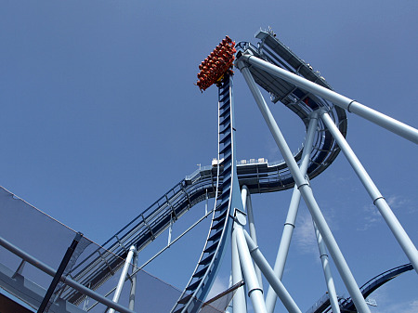

Name: The Griffon
Location: Busch Gardens Williamsburg, Virginia
Type: Hyper coaster
Track: Steel
Drop: 205 ft
Height: 205 ft
Length: 3,108 ft
Top Speed: 71 miles per hour

Use the Fathom software using graphs, tables, and tests to answer the following questions.

- What roller coaster has the largest drop? Please state the roller coasters name, location, what type of roller coaster it is, and the value of the drop?

- What roller coaster has the smallest drop? Please state the roller coasters name, location, what type of roller coaster it is, and the value of the drop?

- What is the mean of the largest drop? How does this relate to the graph and the rest of the data?

- What roller coaster has the largest height? Please state the roller coasters name, location, what type of roller coaster it is, and the value of the height?

- What roller coaster has the smallest height? Please state the roller coasters name, location, what type of roller coaster it is, and the value of the height?

- What is the mean of the heights? How does this relate to the graph and the rest of the data?

- Compare the height and largest drop. Do they have a positive, negative, or no clear correlation? What is the value of r^2?

- What roller coaster is the longest? Please state the roller coasters name, location, what type of roller coaster it is, and the value of the length?

- What roller coaster has the shortest length? Please state the roller coasters name, location, what type of roller coaster it is, and the value of the length?

- What is the mean of the lengths? How does this relate to the graph and the rest of the data?

- What roller coaster has the highest speed? Please state the roller coasters name, location, what type of roller coaster it is, and the speed?

- What roller coaster has the lowest speed? Please state the roller coasters name, location, what type of roller coaster it is, and the speed?

- What is the mean of the speeds? How does this relate to the graph and the rest of the data?

- Compare the length and top speed. Do they have a positive, negative, or no clear correlation? What is the value of r^2?

Lesson Plan Template MATE 4001 (2013)

Title: An interactive learning lesson using the Fathom software to analyze graphs and data.
Subject Area: Mathematics
Grade Level: Math 2 (9-12)
Concept/Topic to teach: Use statistics appropriate to the shape of the data distribution to compare center (median, mean) and spread (interquartile range, standard deviation) of two or more different data sets.

Learning Objectives:

Essential Question
How does your favorite roller coaster compare to the sample of roller coasters given?

Standards addressed:
- Common Core State Mathematics Standards:
- S-ID.1 Represent data with plots on the real number line (dot plots, histograms, and box plots).
- S-ID.2 Use statistics appropriate to the shape of the data distribution to compare center (median, mean) and spread (interquartile range, standard deviation) of two or more different data sets.
- S-ID.3 Interpret differences in shape, center, and spread in the context of the data sets, accounting for possible effects of extreme data points (outliers).
- S-ID.8 Compute (using technology) and interpret the correlation coefficient of a linear fit

- Common Core State Mathematical Practice Standards:
- 2. Reason abstractly and quantitatively
- 3. Construct viable arguments and critique the reasoning of others.
- 4. Model with Mathematics.
- 5. Use appropriate tools strategically.
- 6.Attend to precision

- Technology Standards:

HS.TT.1 Use technology and other resources for assigned task
HS. TT. 1.1 Use appropriate technology tools and other resources to access information
HS. TT. 1. 2 Use appropriate technology tools and other resources to organize information.

Required Materials:
Computers/laptops, graphing calculators, Fathom software, Pencil, Paper

Notes to the reader:
Students should have prior knowledge on how to use Fathom.

Time: Assume 60 minutes ***

Time | Teacher Actions | Student Engagement
10- min | - The teacher will have previously, the day before, asked the students for homework, or during a class visit to the computer lab, to research their favorite roller coaster they have ever been on. If a student has not ever been on a roller coaster then have the student research a roller coaster they would like to ride or are to afraid to ride. They would need to find the name of the roller coaster, location, track type, roller coaster type, largest drop of the ride, height, length, and top speed. The teacher will begin the current lesson by asking the students to locate their research and split up into groups of two to talk about their findings. | - Students will retrieve their homework from the night before with information on their favorite roller coasters. Students will then separate into groups of 2 and discuss their findings with a partner. After a brief discussion, the students will receive their teacher’s favorite roller coaster findings on a worksheet. Connected to this worksheet will be their activity for the rest of the lesson.
15 min | - Next, the teacher will pass out his/her findings on their favorite roller coaster and introduce the Fathom software. The teacher will have the roller coaster collection already available on Fathom. Then the teacher will show the students how to drag a table down onto the given space and drag the collection data to the table. The data then will be available in the table.  - The teacher will then ask the students to read the information off of the table, preferably 15 volunteers, and discuss each roller coaster. Next the teacher will pass out the worksheet given for this activity. The activity is asking the students to use Fathom to make a decision on what their favorite type of roller coaster would be under the given criteria. The teacher will then show students how to do this. The teacher will drag the graph option down onto the given space and then drag the column of “type of roller coaster” to the x-axis. A bar chart should appear and students will see that hyper coasters are the most common between this given sample. Explain to the students how a sample is different than a population.  - Next the teacher will create a graph with the “type of roller coaster” as the x-axis and the “largest drop” as the y-axis. Talk about the graph asking students question about the mean, maximum, and minimum. Record all of the information. Then drop down the summary box and drag the “largest drop” onto the box. This will show the mean.
10 min | - After showing the “largest drop” have students work independently in their groups to work on the height. Repeating the same steps as the teacher. Once the students have finished, show the students how to find the regression line. Students may not have previous knowledge of what this is, but information should be given on their worksheet. Open up a graph and drag the “largest drop” onto the x-axis and “height” onto the y-axis. Then right click and select “Least-Squares Line.” This should create a line of best fit. Explain to the students how this is a positive correlation because as the largest drop increases the height increases. Record the equation at the bottom of the graph. Explain to the students how the “r squared” in statistics is the measure of how well a set of data points fit a line or graph. The closer r squared is to 1, the more accurate the graph is.
55 minutes | - Have students finish the worksheet following the same steps as shown in class. Teacher should be walking around asking questions and listening to the groups.  - Finish the class by comparing and analyzing the information recorded on the worksheet to the teacher’s favorite roller coaster.  - For homework ask each student to compare the data they found in their groups to their favorite roller coaster.

Reflection: I believe that this task is very engaging for students and teachers. It allows both components to get out of the classroom and work one on one with a real world application that involves math. By using Fathom, I can teach my students about correlation and allow them to get a deeper understanding on how to construct and read graphs.

